CMOS AND Gate Simulation using TSMC 0.18µm Technology
_______________________________________________________________________________
Overview
This project implements a CMOS AND gate in LTspice using TSMC 0.18µm process technology parameters. The circuit is designed using NAND gate + inverter topology for efficient transistor-level implementation.

Circuit Description
First Stage (NAND Gate)
PMOS (M3, M4) in parallel → Pull-up network
NMOS (M1, M2) in series → Pull-down network
Output produces the NAND function
Second Stage (Inverter)
PMOS (M5) and NMOS (M6) form a standard CMOS inverter
Inverts the NAND output to produce the AND function
Power Supply: VDD = 5V
Technology File: .include tsmc018.lib loads the TSMC 0.18µm device models

Input Signals:
V1 → Input A (PULSE signal)
V2 → Input B (PULSE signal)
Both are configured for transient analysis to verify truth table
__________________________________________________________________________________
Sizing Summary
--------------------------------------------------------------------------------------------------------------------------------------
This project demonstrates the design, sizing, and LTspice simulation of a basic CMOS inverter using the TSMC 0.18 µm PDK.
The focus is on achieving balanced rise and fall times by properly sizing the PMOS and NMOS transistors according to the mobility ratio.

In CMOS logic, PMOS is made wider to compensate for its lower hole mobility compared to NMOS electron mobility.
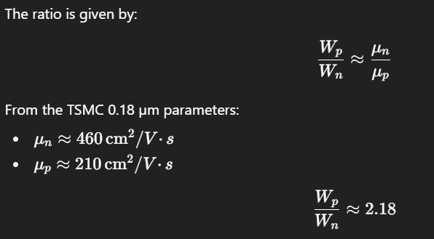
Use inverter-equivalent effort rules — keep the equivalent drive of the gate near that of a single inverter.
- 2-input NAND
  - NMOS: 2 series devices → each NMOS width ≈ 2 × Wn (so each ≈ 2.0 µm)
  - PMOS: two PMOS in parallel → each PMOS keep ≈ Wp (≈ 2.18 µm)
- N-input stacked (k series devices): size each series device ≈ k × Wunit.
• L = 0.18 µm (NMOS and PMOS)
• Wn (NMOS unit) = 1.0 µm
• Wp (PMOS unit) = 2.18 µm (Wp/Wn ≈ 2.18 from your BSIM U0 values)

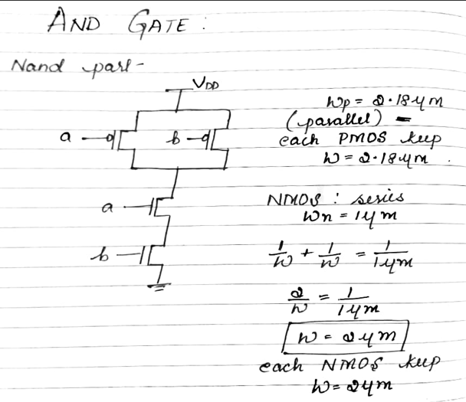

CMOS OR Gate Simulation using TSMC 0.18µm Technology
- Logic Structure:
  - Step 1: NOR gate (PMOS in parallel, NMOS in series)
  - Step 2: Inverter to invert NOR output → OR logic output
- Technology: TSMC 0.18 µm process (tsmc018.lib)
- Power Supply: VDD = 5 V
- Transient Analysis: .tran 0 200n to verify output switching
Transistor Sizing (for balanced rise/fall times)
- Channel Length (L): 0.18 µm (same for all devices)
- NMOS Width (Wn): 1.0 µm
- PMOS Width (Wp): ≈ 2.2 µm (Wp/Wn ≈ 2.18)
